FITDAY SYSTEM

Table of Contents

*Page Number*

1) Introduction ………………………………………………………………………………………………………………………. 2

2) Abstract …………………………………………………………………………………………………………………………….. 3

3) Use cases …………..………………………………………………………………………………………………………………. 3

5) Enhanced Entity Relationship (EER) Diagram......…………………………………………………….………….. 6

6) Normalization ……………………………………………………………………………………………………………………. 8

7) De-Normalization ……………………………………………………………………………………………………………… 8

7) Assumptions made for the database …………………………………………………………………………………..9

8) Calculation procedure ………………………………………………………………………………………………………. 11

9) Functions ……………….…………………………………………………………………………………………………….….. 15

10) Triggers …………………………………………………………………………………………………………..……………….. 19

11) Views ……………………………………………………………………………………………………………………………….. 23

12) Users and privileges ………………………………………………………………………………………………………….. 27

13) Results and discussion ……………………………………………………………………………………………………… 30

14) Conclusion ……………………………………………………………………………………………………………………….. 34

15) Future scope ……………………………………………………………………………………………………………………. 35

**INTRODUCTION**

Over 21 million people of the population are suffering from diabetes in USA alone. More than 8 million people have diabetes, yet unaware about it. Common symptoms of diabetes: Cuts/bruises that are slow to heal, Feeling very hungry - even though you are eating. Current diagnosing technique involves invasive blood tests such as Random blood sugar test Fasting blood sugar test. Necessity of noninvasive technique to continuously monitor glucose is the need of the hour. FitDay foresees that fitness tracker devices will include biosensors to monitor a Diabetic patient in the near future. Having glucose information as easy as heart rate or calories burned will be vital to live a healthy life.

**USE CASES**

The FitDay system identifies three main use cases:

1. FitDay System User

User registers himself in the FitDay system as **Athlete** and/or **Patient**.The system stores diabetic measures or activity data from user’s device. Analysis of User Data is done and appropriate suggestions are made.

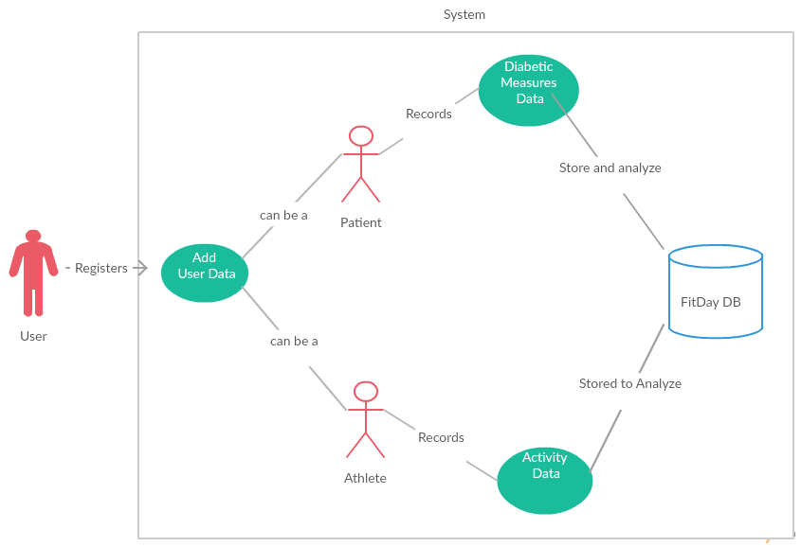

1. Doctor Patient

FitDay system after processing diabetic measures of each patient provides suggestion to doctor. Doctor refers to the system suggestion and prescribes treatment to the patient

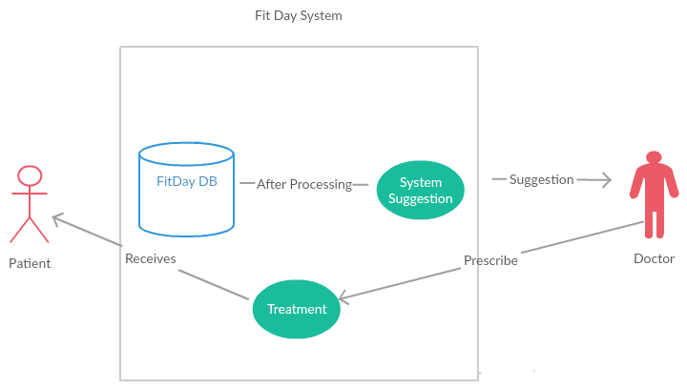

1. Athlete

Athlete activity and vital signs are recorded in the system and stored in the FitDay database for analysis. The system analyzes heart rate and suggests remedies to the athlete. Calories burned during the activities are also stored for each athlete.

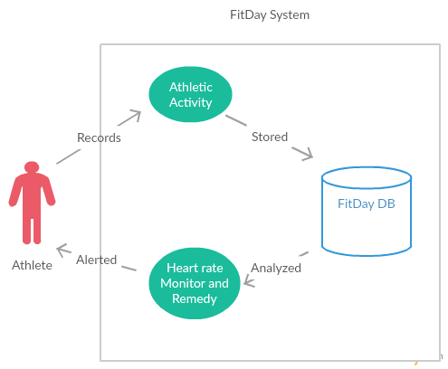

**ENHANCED ENTITY RELATIONSHIP DIAGRAM**

An EER diagram was made for the entire database, encompassing all the above mentioned roles and other relevant data sets.

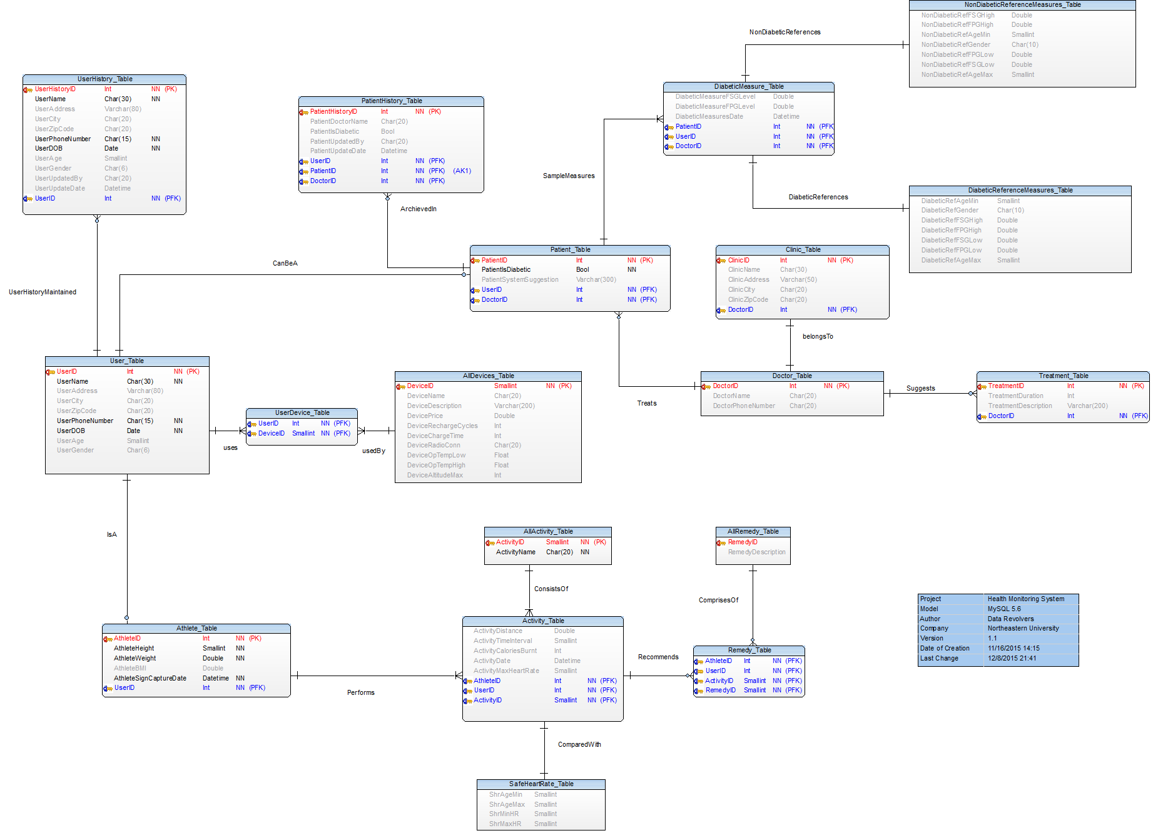

**NORMALIZATION**

As with most databases, this database aimed to achieve the third normal form (3NF) level of normalization for all tables. The definition of the 3NF normalization is that all the attributes in a table are directly related to only the primary key and no other attribute.

Normalized databases fair very well under conditions where the applications are write-intensive and the write-load is more than the read-load.Main cause of concern with fully normalized tables is that normalized data means joins between tables. Joining means that read operations have to suffer because indexing strategies do not go well with table joins.

**DE-NORMALIZATION**

Denormalized databases fair well under heavy read-load and when the application is read intensive. The data is present in the same table so there is no need for any joins, hence the selects are very fast.A single table with all the required data allows much more efficient index usage. Selects can be very fast on denormalized tables, but because the data is duplicated, the updates and inserts become complex and costly. Denormalized schema greatly improves performance with efficient use of triggers.

**ASSUMPTIONS MADE FOR THE DATABASE**

Data isn’t 100% factual – interpolated and extrapolated with existing data. Patients have already been diagnosed with diabetes and doctor is monitoring patient through FitDay system. Continuous diabetic measures are being collected from patients and fed into the FitDay system. FitDay system gives suggestion to doctors and doctor prescribes appropriate treatment accordingly. Athletes are recording their activity details in the FitDay system.

**CALCULATION PROCEDURE**

For running activity on flat surface: CB = [0.0215 x KPH3 - 0.1765 x KPH2 + 0.8710 x KPH + 1.4577] x WKG x T

CB = Calorie burn (in calories)   
KPH = Running speed (in kilometers per hour)   
WKG = Weight (in kilograms)   
T = Time (in hours)

For Diabetic patients:

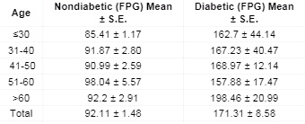

**FUNCTIONS**

Functions to facilitate Calories Burned calculation

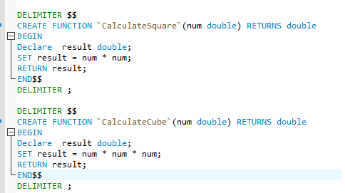

**TRIGGERS**

Database trigger is powerful tool for protecting the integrity of the data in your MySQL databases. Database triggers are very useful to automate some database operations such as audit logging.

Insert Trigger to suggest doctor the Level of FSG & FPG in a patient

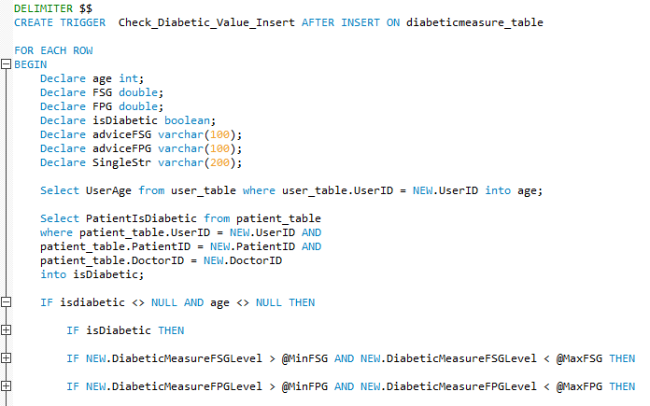

Update Trigger to suggest Athlete the Remedy after a given activity

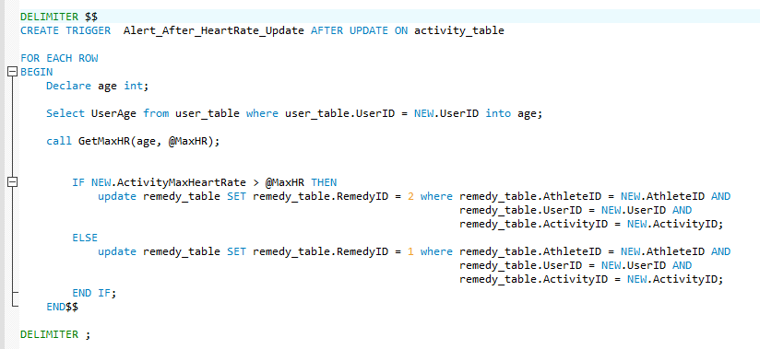

Trigger to archive patient data when patient’s diabetic state is changed

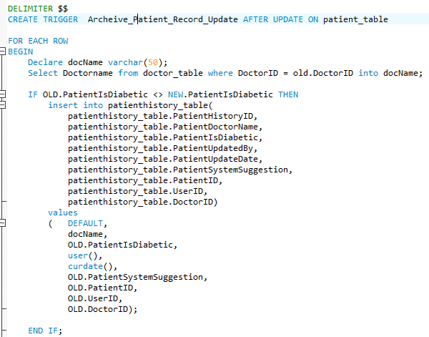

**VIEWS**

A database view is known as a “virtual table” that allows you to query the data in it. Understanding database views and using them correctly are very important. In this section, we will discuss about the database views, how they are implemented in MySQL, and how to use them more effectively.

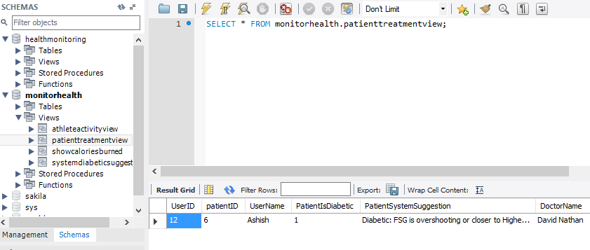

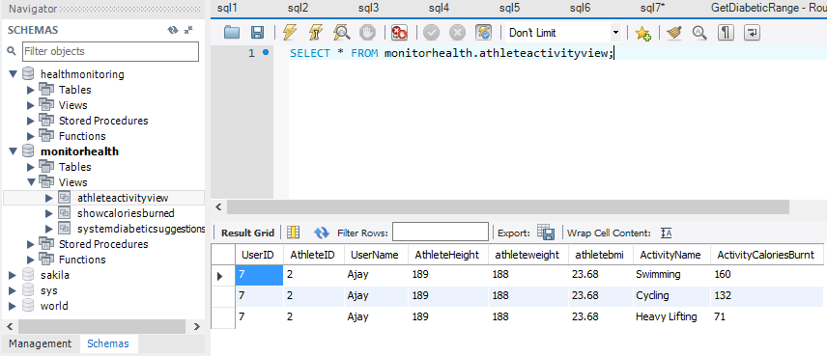

**USERS AND PRIVILEGES**

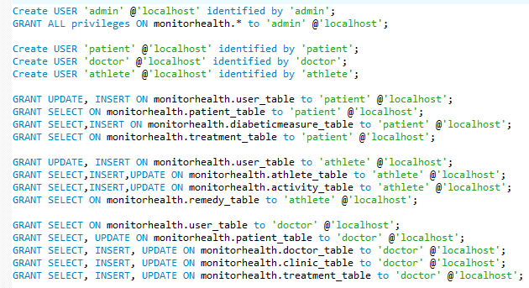

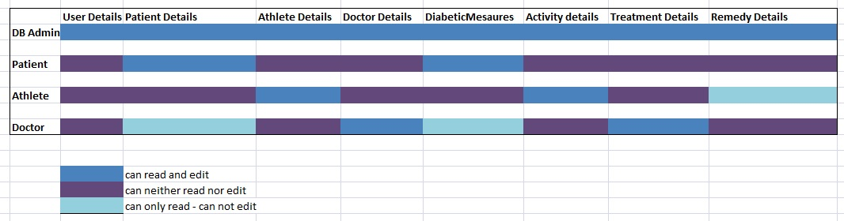

**STORED PROCEDURES**

Get Diabetic Range for particular age group

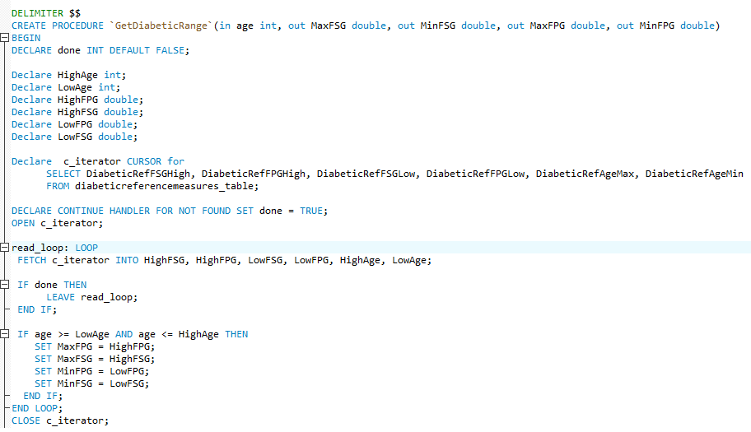

Get Maximum Safe Heart Rate for given age group

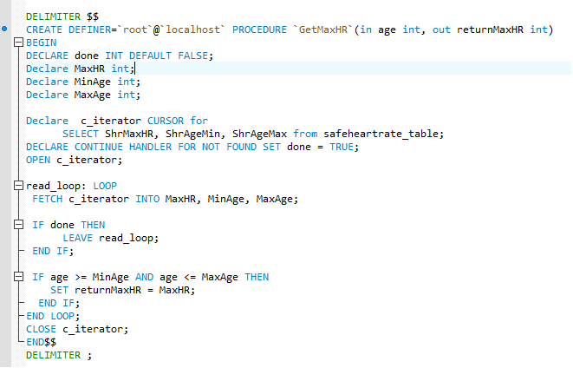

**Get Calories burned for an Athlete in given Activity**

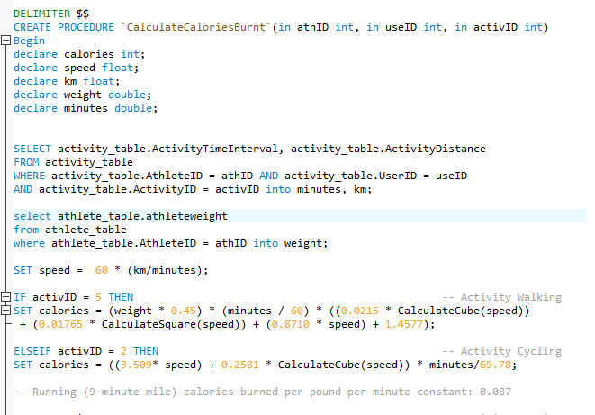

**INDEX**

An index is used to speed up the performance of queries. It does this by reducing the number of database data pages that have to be visited/scanned. In MySQL InnoDB, a clustered index determines the physical order of data in a table. There can be only one clustered index per table (the clustered index IS the table)

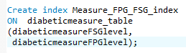

RESULTS:

**For Diabetic patient:**

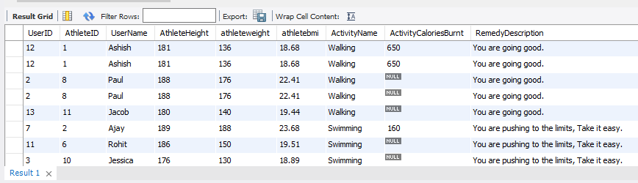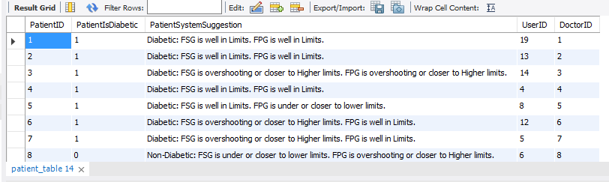

**For Athlete:**